* Homework of Numerical Analysis:
* Subhrajyoty Roy

Roll No- BS-1613

For polynomial interpolation with equally spaced points, we had the expression of the error;

$e_{n}\left(x\right)=f\left(x\right)-P_{n}\left(x\right)=\frac{f^{\left(n+1\right)}\left(ξ\right)}{\left(n+1\right)!}×Π_{n}(x)$ where we have $ξ∈H\{x_{0}, x_{1},…x_{n}\}$.

From these we got, if $M_{n}=\max_{I}{|f^{\left(n+1\right)}(ξ)|}$ then $\left|e_{n}\left(x\right)\right|≤\frac{M_{n}}{\left(n+1\right)!}×\max_{I}{|Π_{n}(x)|}$.

From this point of view, we want to minimize $\max_{I}{|Π_{n}(x)|}$ so that the errors, on average, would be less. Consider, **n=6**. Therefore, we have 7 points to consider,

$Π_{6}\left(x\right)=(x-x_{0})(x-x_{1})(x-x_{2})(x-x_{3})(x-x_{4})(x-x_{5})(x-x_{6})$.

Now, writing $\left(x_{i}-x_{i-1}\right)=h ∀i=1,2…6$ and $\frac{\left(x-x_{3}\right)}{h}=w$ we get the expression;

$$Π_{6}\left(w\right)=\left(w-3\right)\left(w-2\right)\left(w-1\right)w(w+1)(w+2)(w+3)$$

$=w\left(w^{2}-1\right)\left(w^{2}-4\right)\left(w^{2}-9\right)$

$={(w}^{3}-w)(w^{4}-13w^{2}+36)$

$=w^{7}-14w^{5}+49w^{3}-36w$.

To find its local maximum and minimums in the interval $\left[x_{0},x_{6}\right], \left[x_{1},x_{5}\right]$ and $[x_{2},x_{4}]$, we differentiate the above expression with respect to w. (Differentiating with respect to x and with respect to w are essentially same as they differ by a constant x3 and change of scale by h.)

Hence, $Π_{6}^{'}\left(w\right)=7w^{6}-70w^{4}+147w^{2}-36=0$,

Rewriting $u=w^{2}$ gives the cubic polynomial to solve $7u^{3}-70u^{2}+147u-36=0$, which has the roots $u_{1}=0.28159, u_{2}=2.54652, u_{3}=7.17189$.

It gives the approximate roots of the equation as,

$w_{1}=-0.53065$, $w_{2}=0.53065$, $w_{3}=-1.59578$, $w_{4}=1.59578$, $w_{5}=-2.67804$ and $w_{6}=2.67804$.

These are the points where the maximum of $|Π_{n}(x)|$ can occur. Eventually, these points are the local maxima as the graph suggests.

There are a few features that can be observed from these;

1. The roots are symmetric about 0, which means the local maximums are at the points distributed symmetrically on both sides of the “middle” of the interval i.e. $x_{3}$.

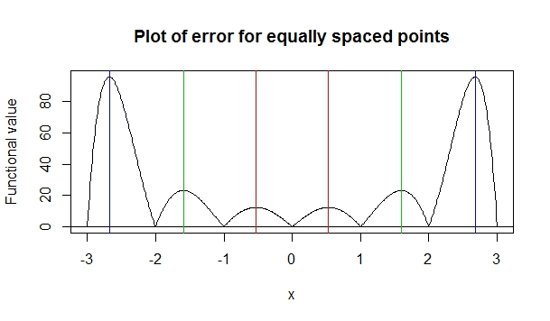2. Observing the modulus of the roots says, $\left|w_{1}\right|=\left|w_{2}\right|≤1$, implying these points lie in the interval $[x_{2},x_{4}]$. Similarly, we have $1<\left|w_{3}\right|=\left|w_{4}\right|≤2$, and $2<\left|w_{5}\right|=\left|w_{6}\right|≤3$.

Computing the value of $Π_{6}(w)$ at $w_{i}$’s we get;

1. $Π_{6}\left(w_{1}\right)=12.359$.
2. $Π_{6}\left(w_{2}\right)=-12.359$.
$Π_{6}\left(w_{3}\right)=-23.149.$

3. $Π_{6}\left(w_{4}\right)=23.149$.
4. $Π_{6}\left(w_{5}\right)=95.842$.
5. $Π_{6}\left(w_{6}\right)=-95.842$.

This values shows that we have the following solution for the given problem.

* In the interval $[x_{2},x_{4}]$, the maximum of $|Π_{6}\left(x\right)|$ occurs at $x=x_{3}±0.53065h$ and the maximum value is $12.359h^{7}$.
* In the interval $[x_{1},x_{5}]$, the maximum of $|Π_{6}\left(x\right)|$ occurs at $x=x_{3}±1.59578h$ and the maximum value is $23.149h^{7}$.
* In the interval $[x_{0},x_{6}]$, the maximum of $|Π_{6}\left(x\right)|$ occurs at $x=x_{3}±2.67804h$ and the maximum value is .